POST: <http://localhost:5000/api/auth/register>

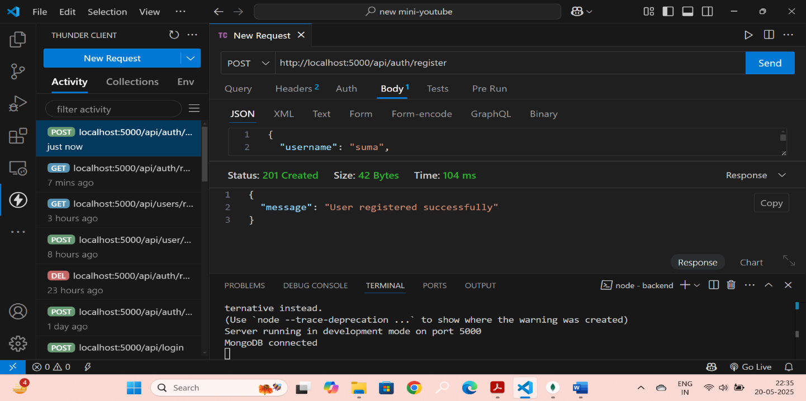

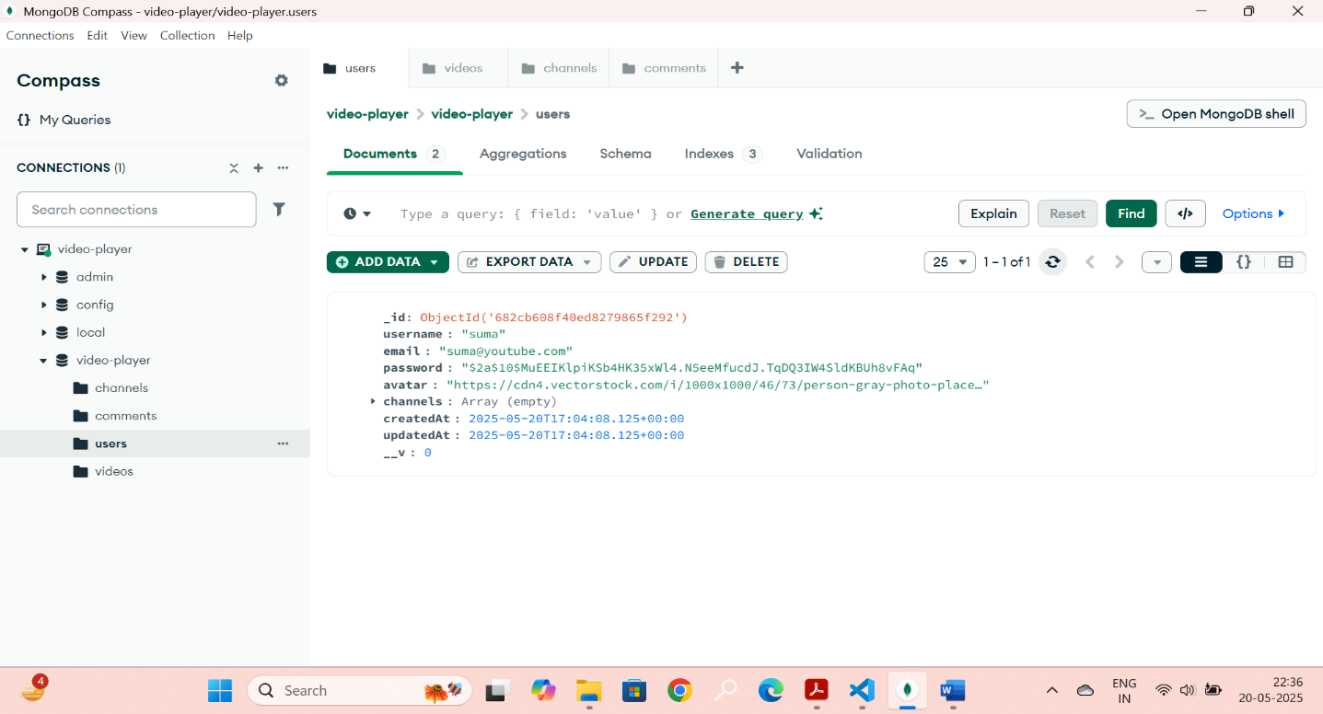

POST : <http://localhost:5000/api/auth/login>

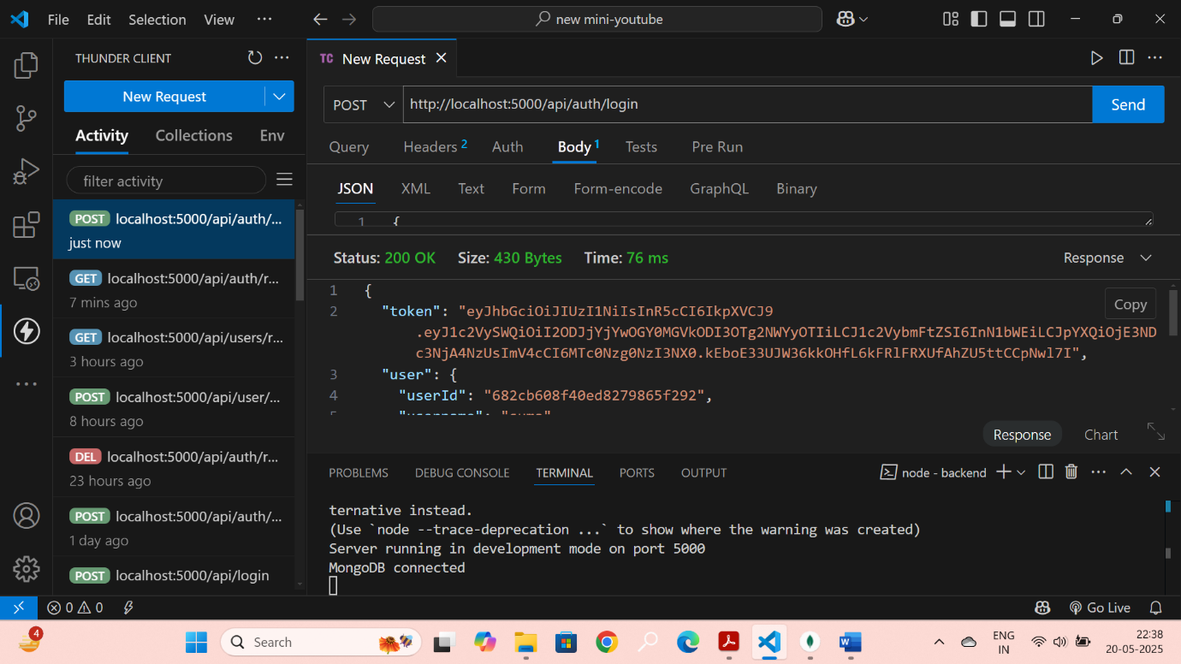

GET : <http://localhost:5000/api/users/profile>

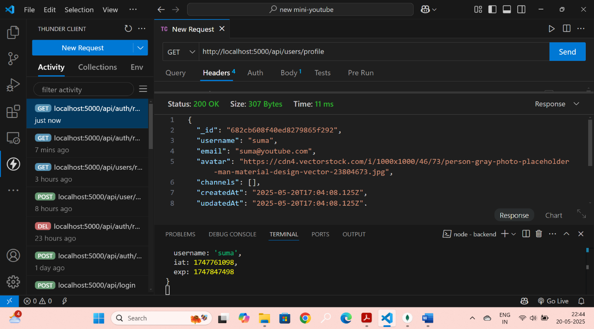

PUT : <http://localhost:5000/api/users/profile>

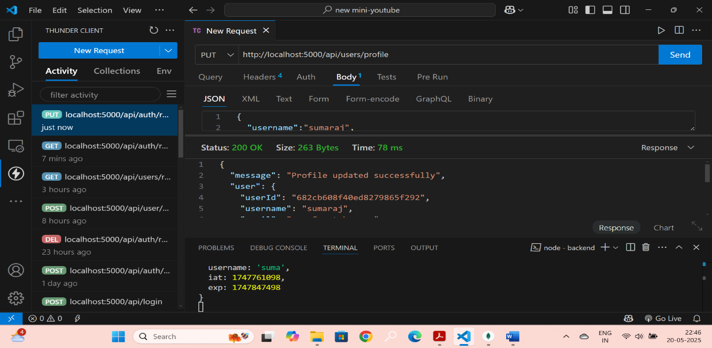

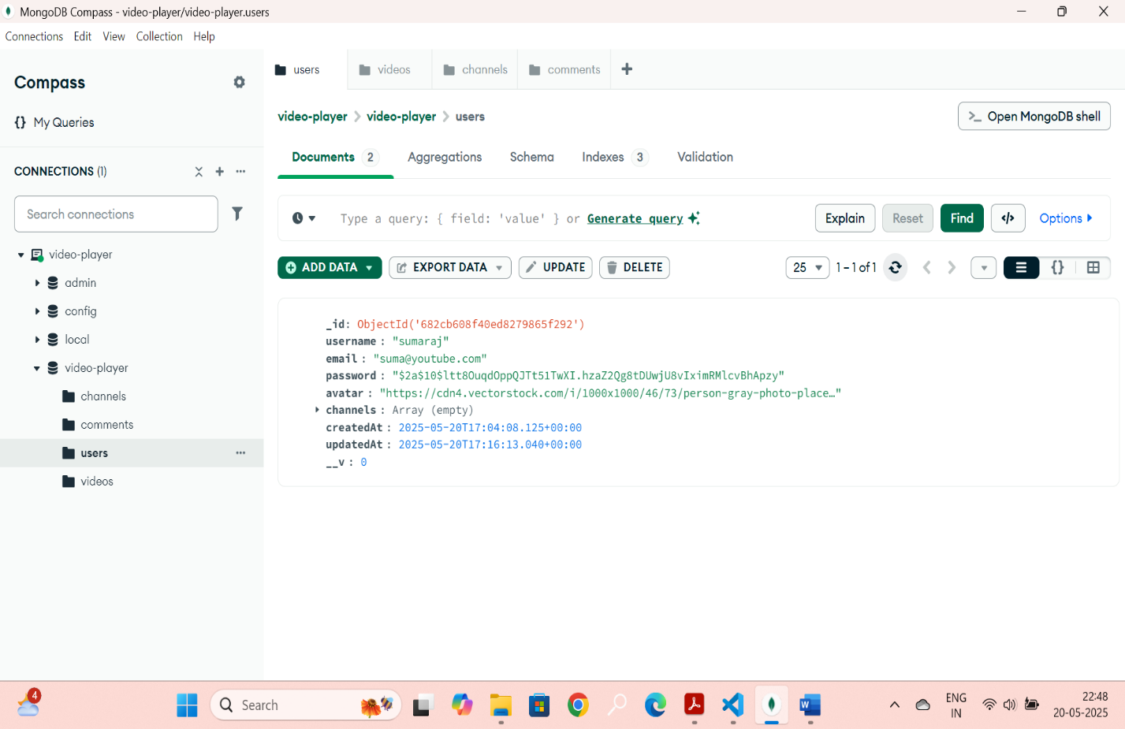

POST : <http://localhost:5000/api/auth/logout>

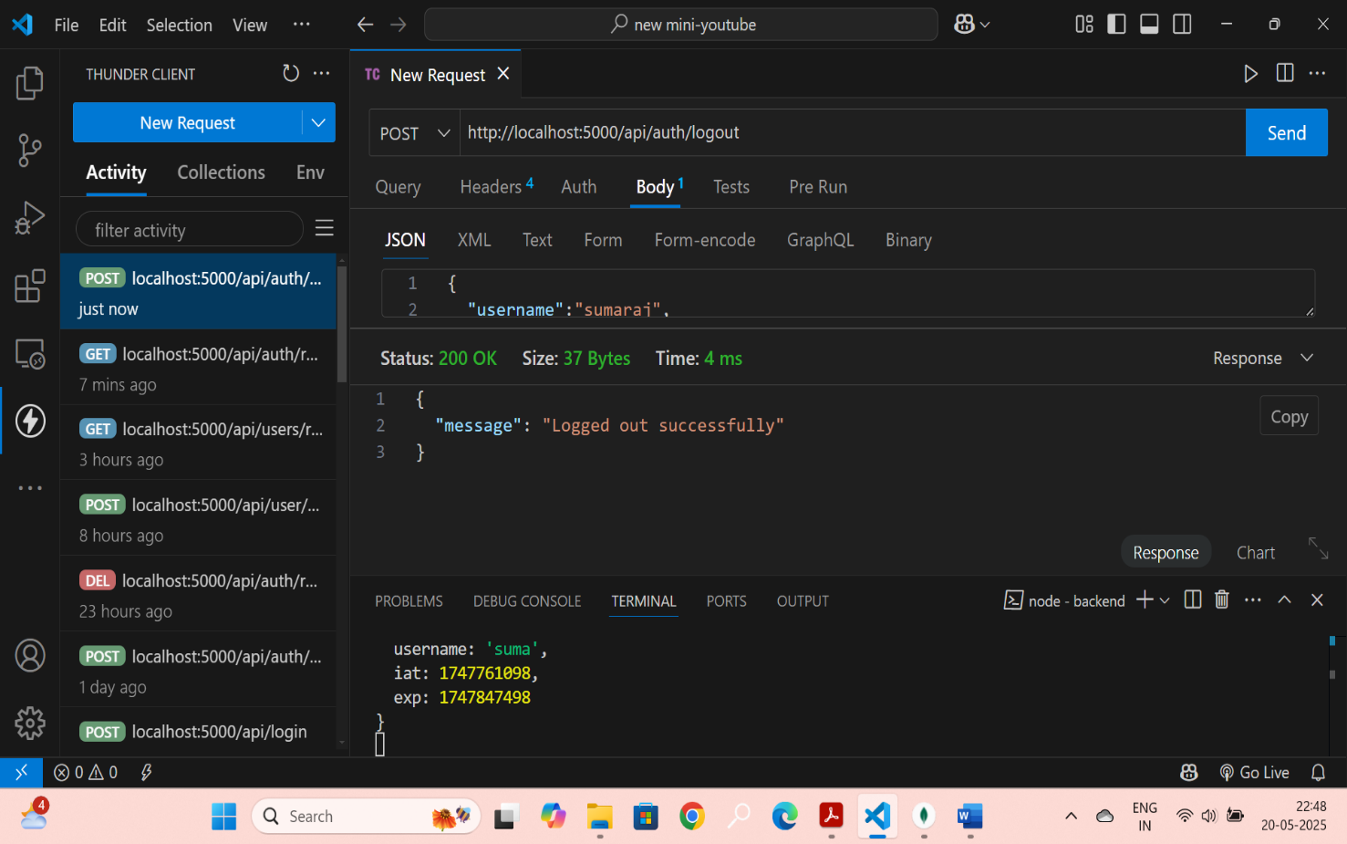

{

"username":"sumaraj",

"email": "suma@youtube.com",

"password":"Radhika@1"

}

POST : <http://localhost:5000/api/channels>

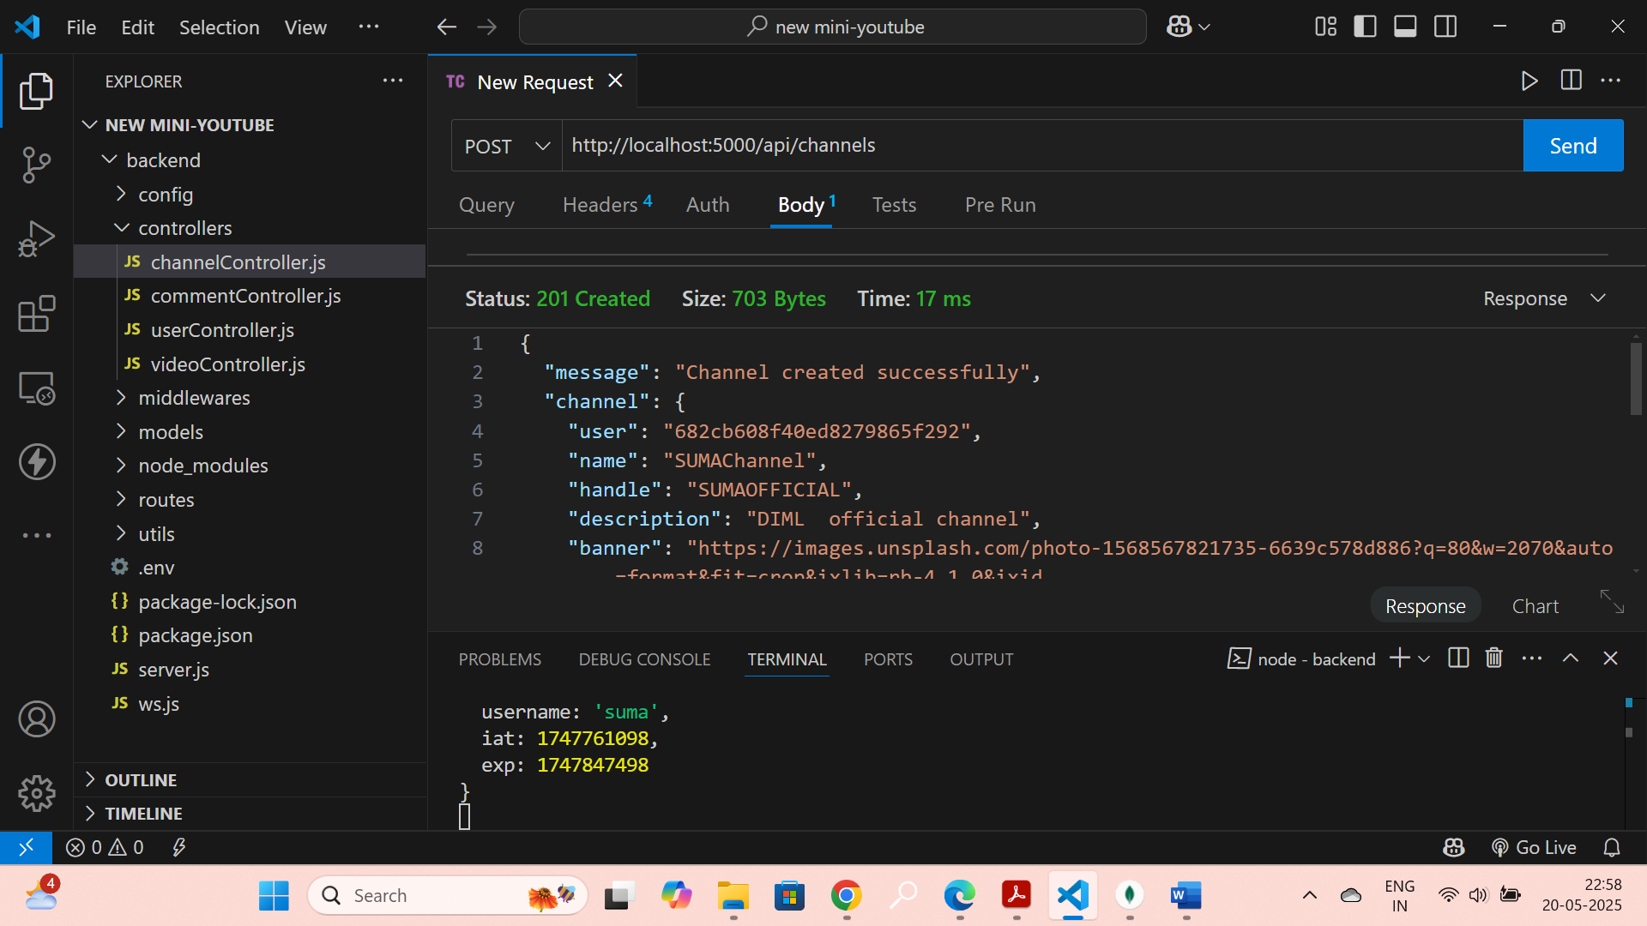

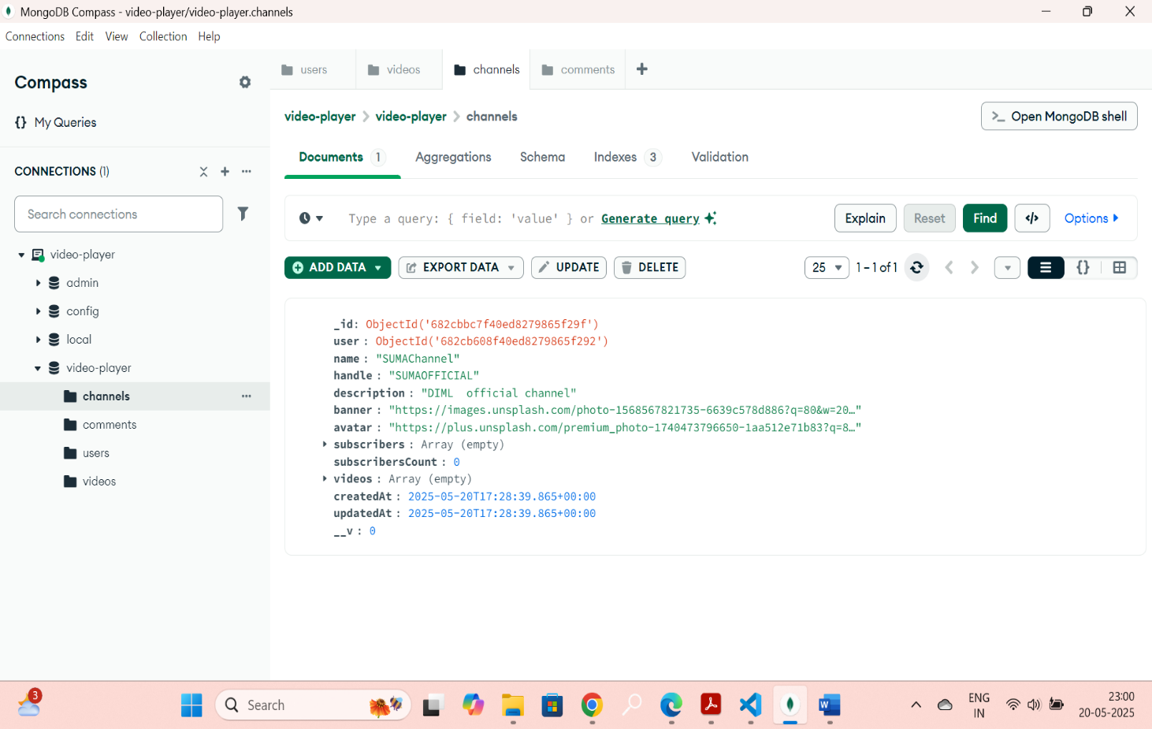

GET : <http://localhost:5000/api/channels/explore>

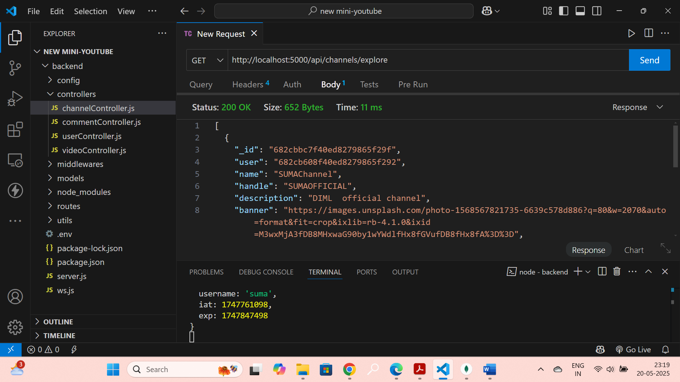

PUT: <http://localhost:5000/api/channels/:CHANNELID>

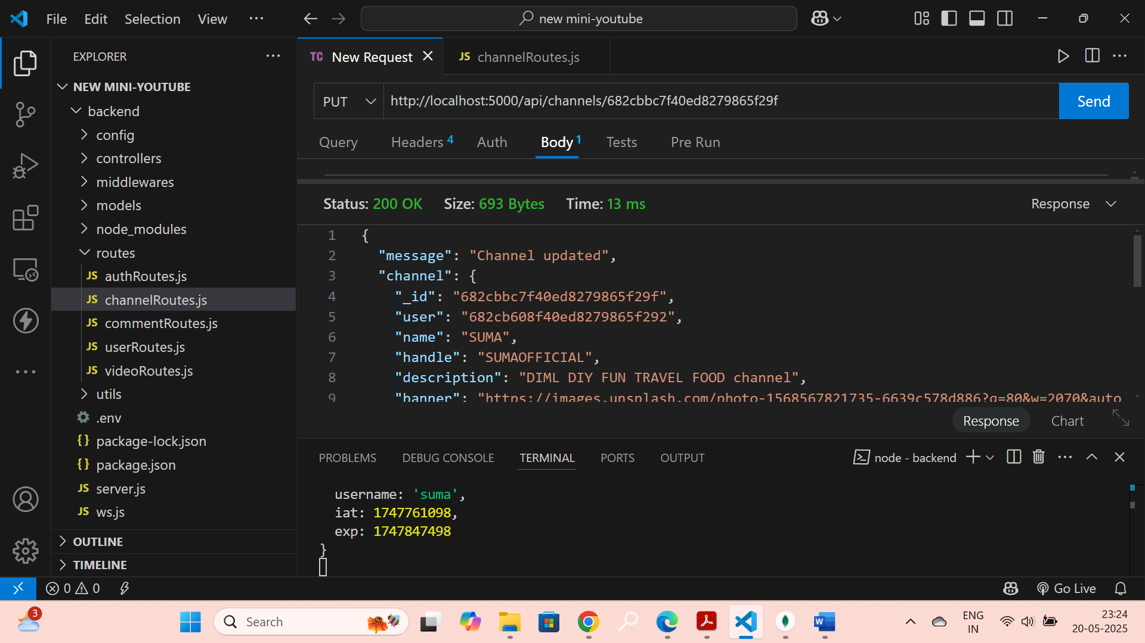

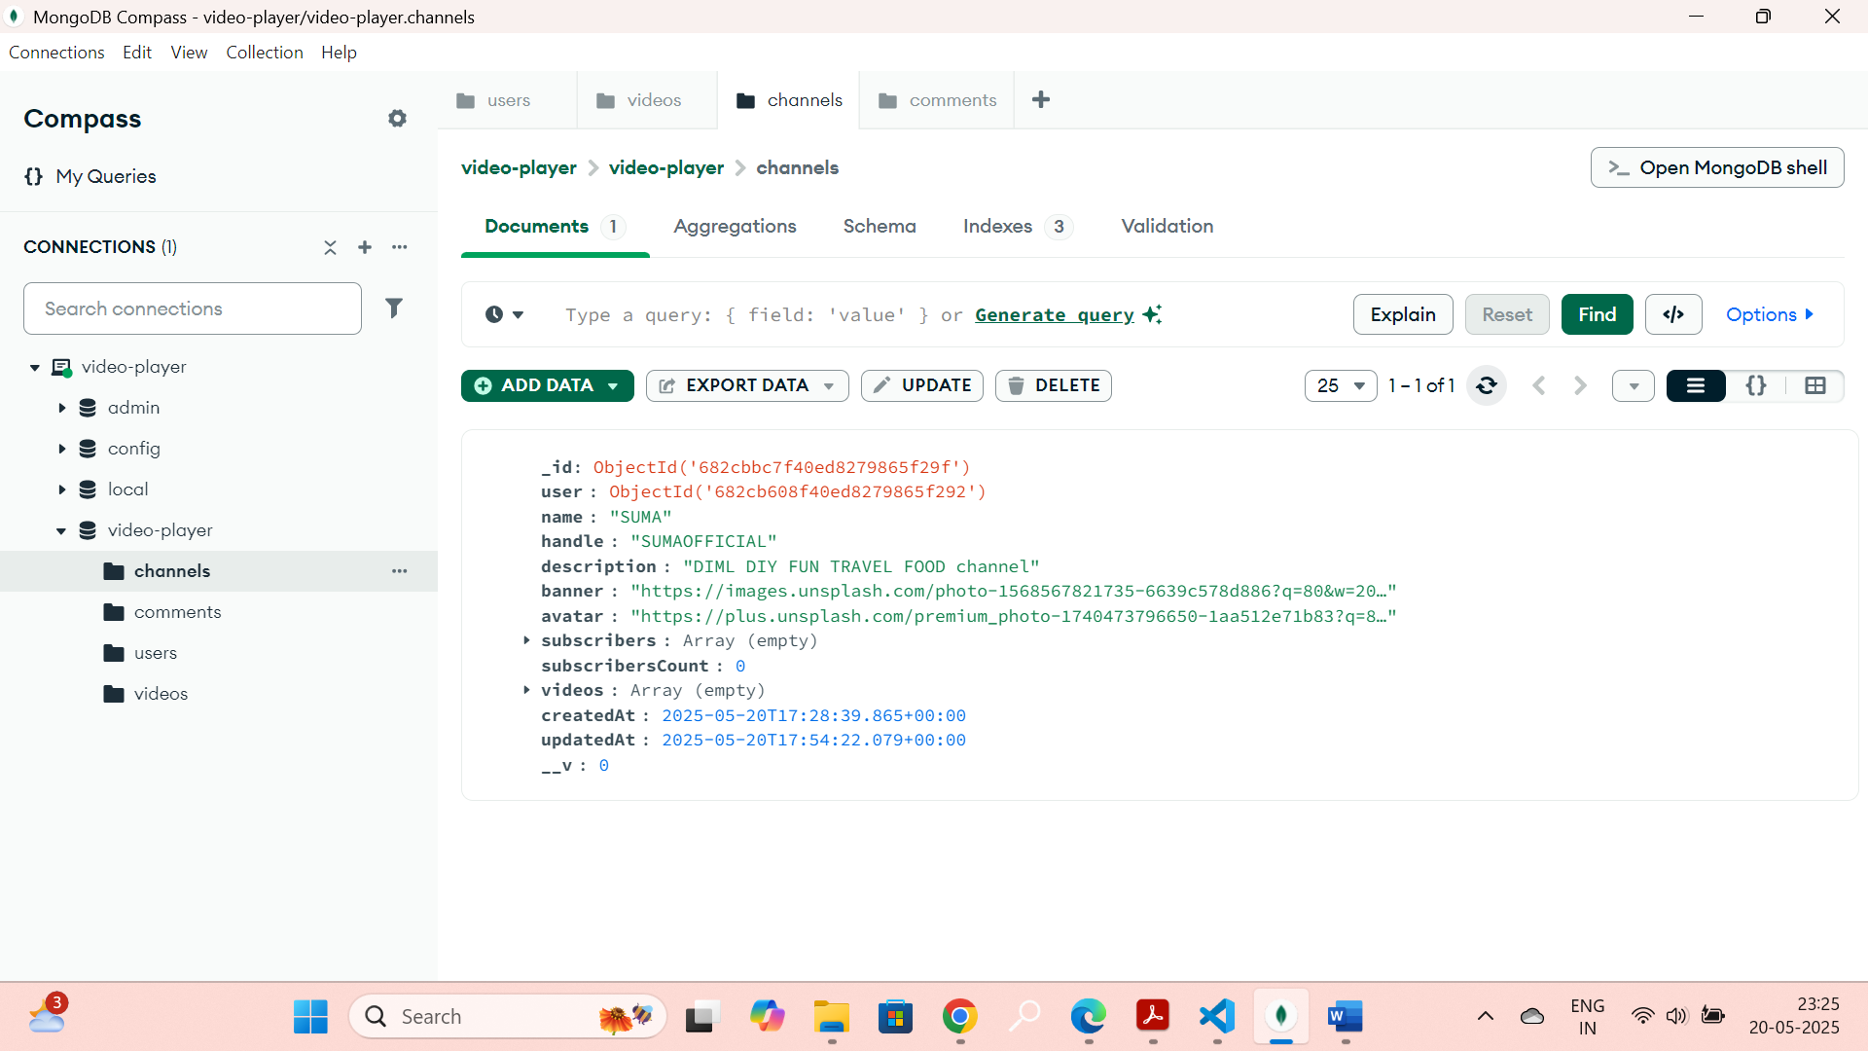

POST : <http://localhost:5000/api/channels/:CHANNELID/subscribe>

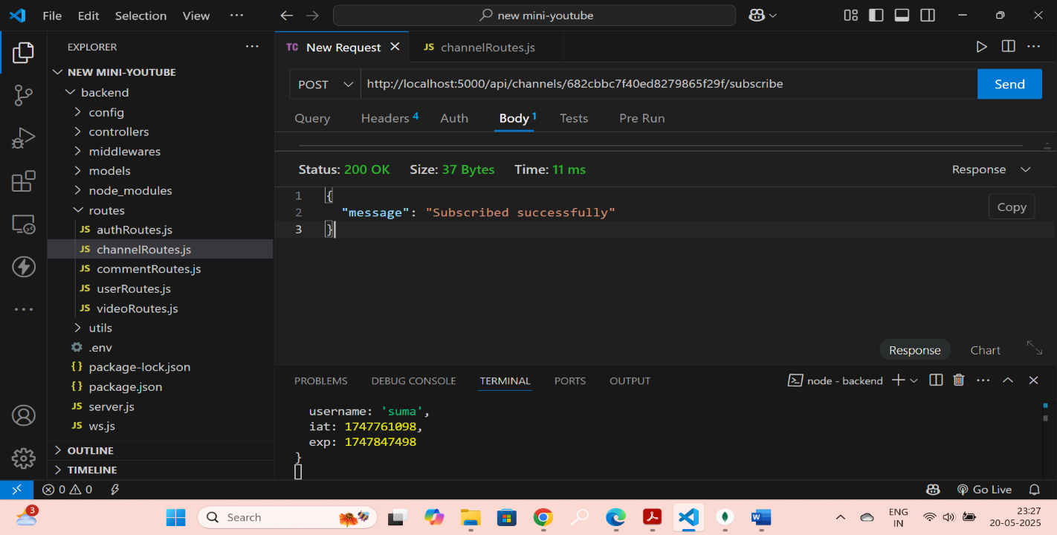

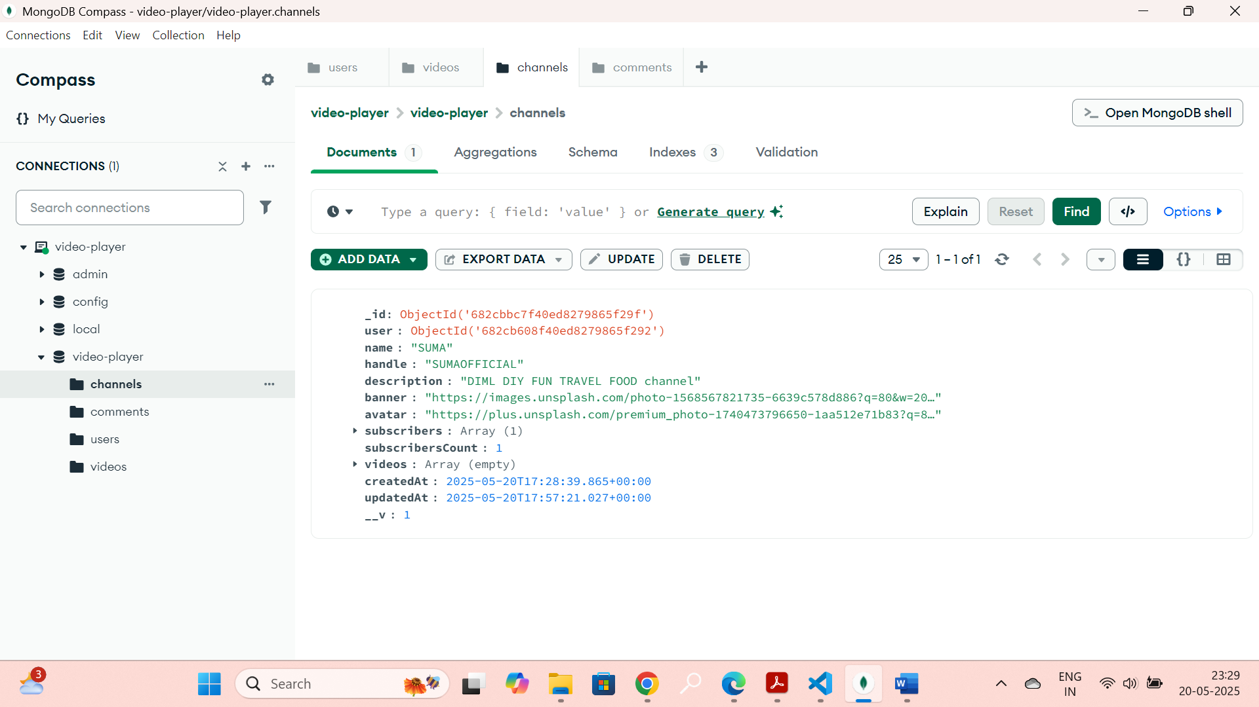

POST: <http://localhost:5000/api/channels/:CHANNELID/unsubscribe>

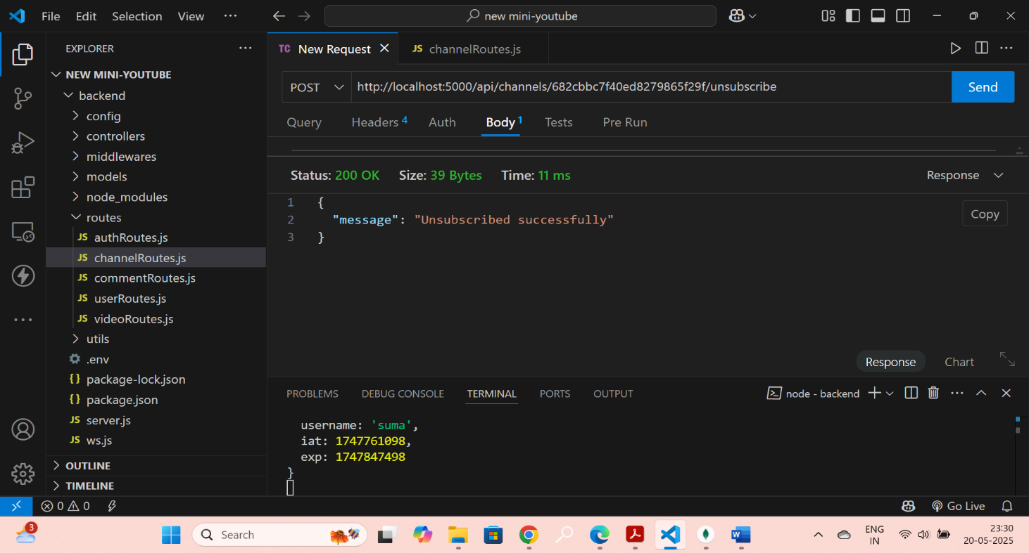

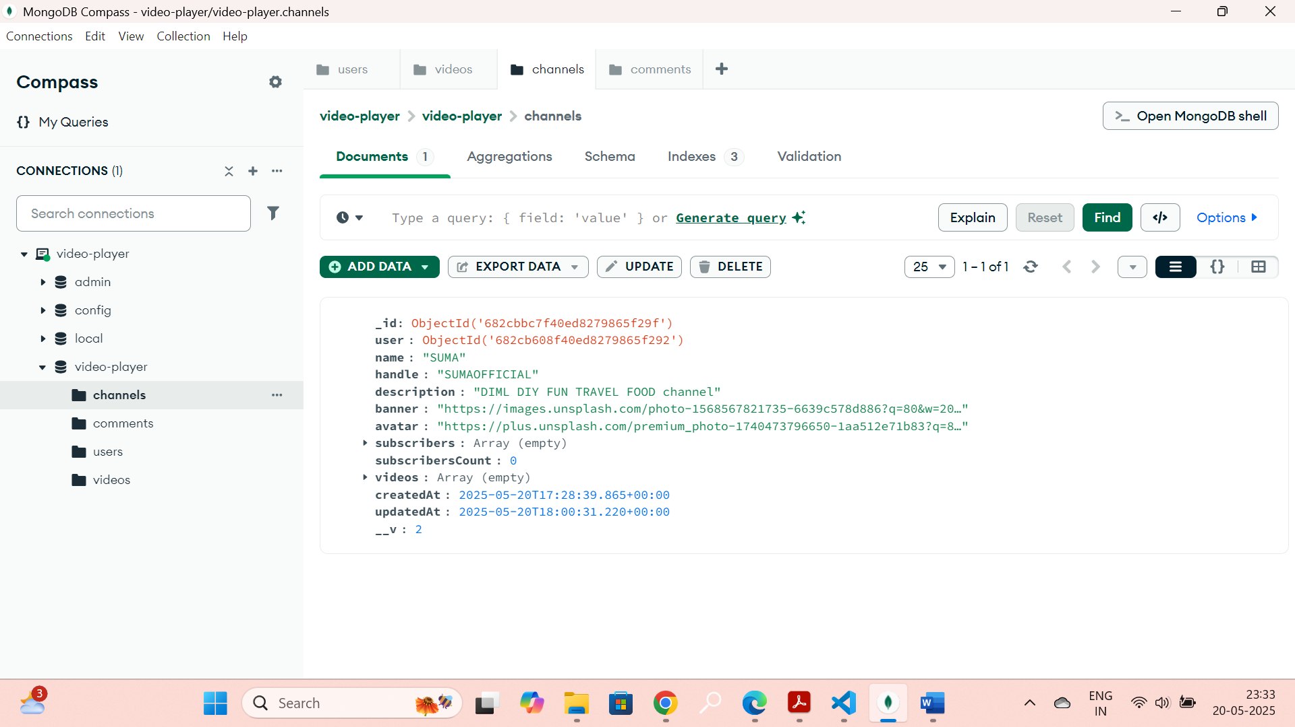

DELETE : <http://localhost:5000/api/channels/:CHANNELID>

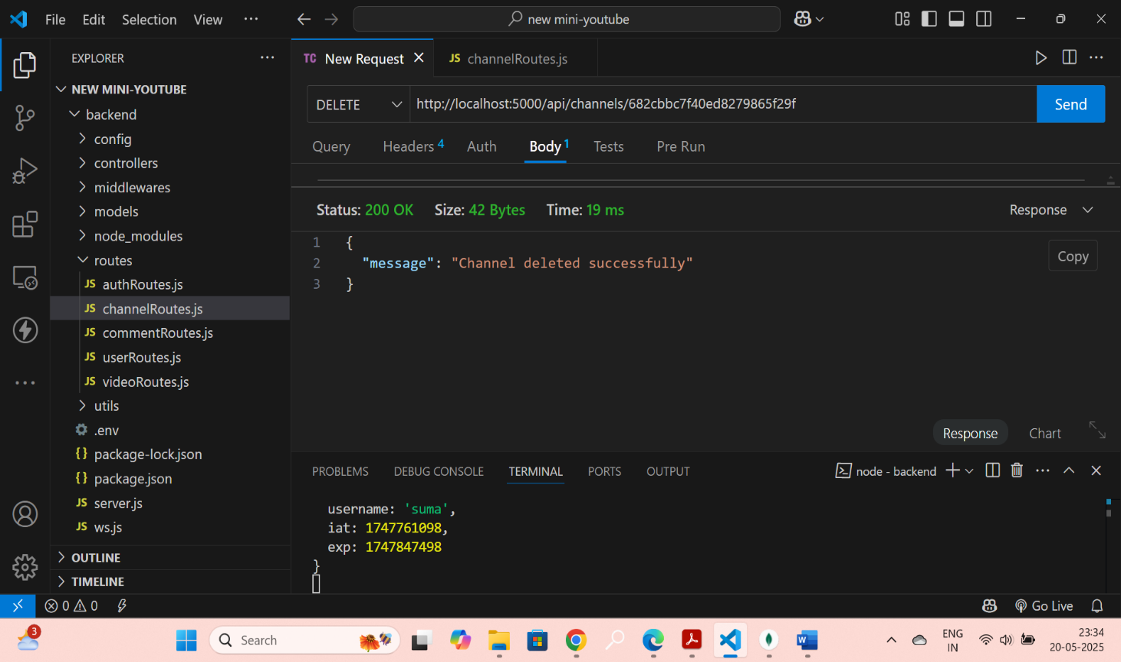

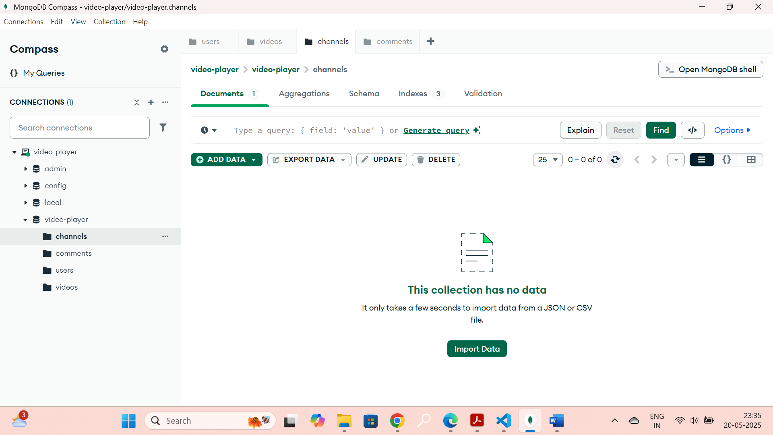

POST: <http://localhost:5000/api/videos>

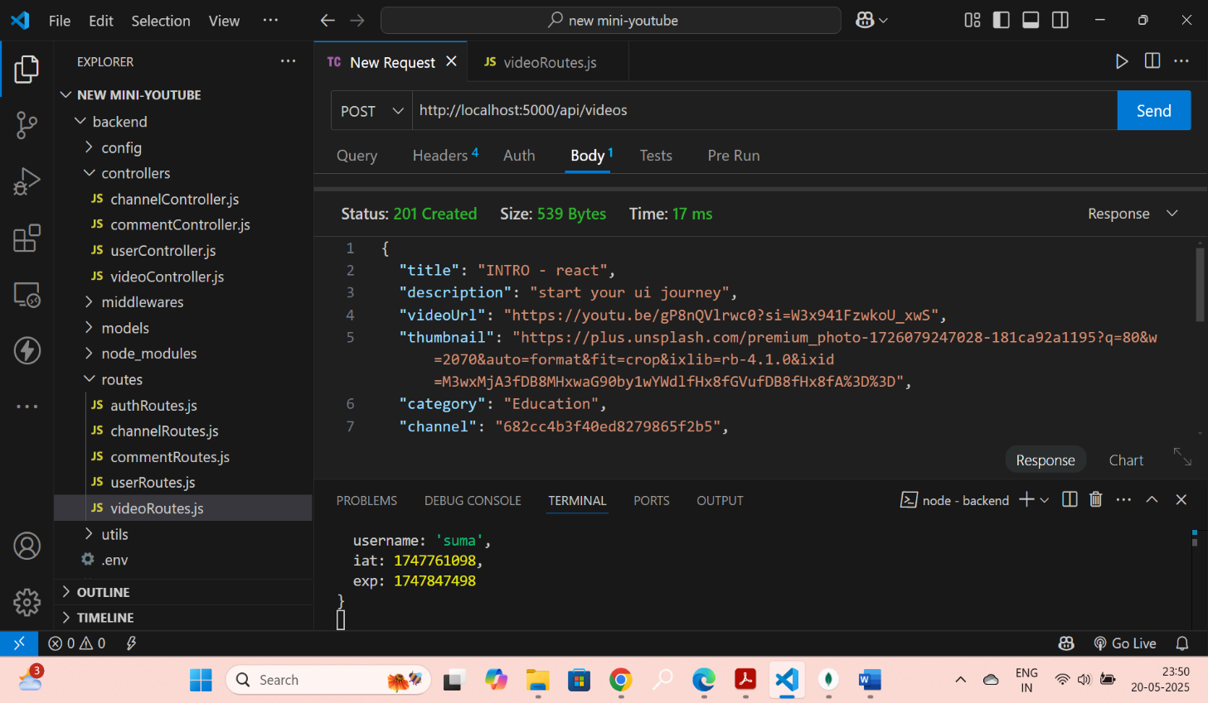

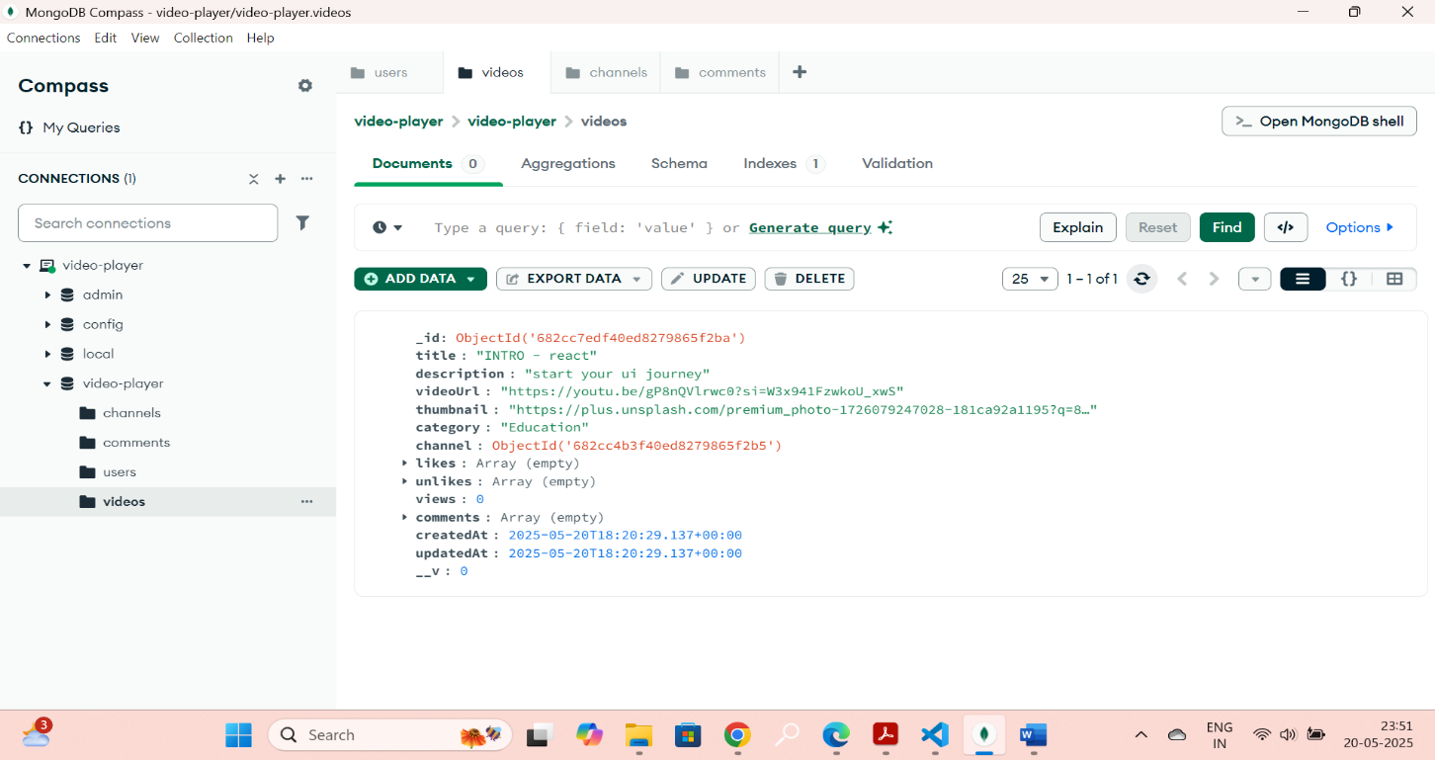

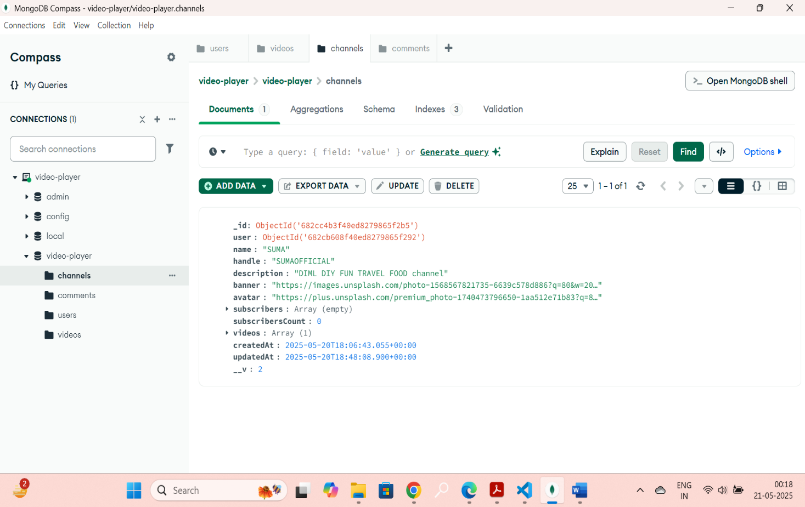

GET : <http://localhost:5000/api/videos>

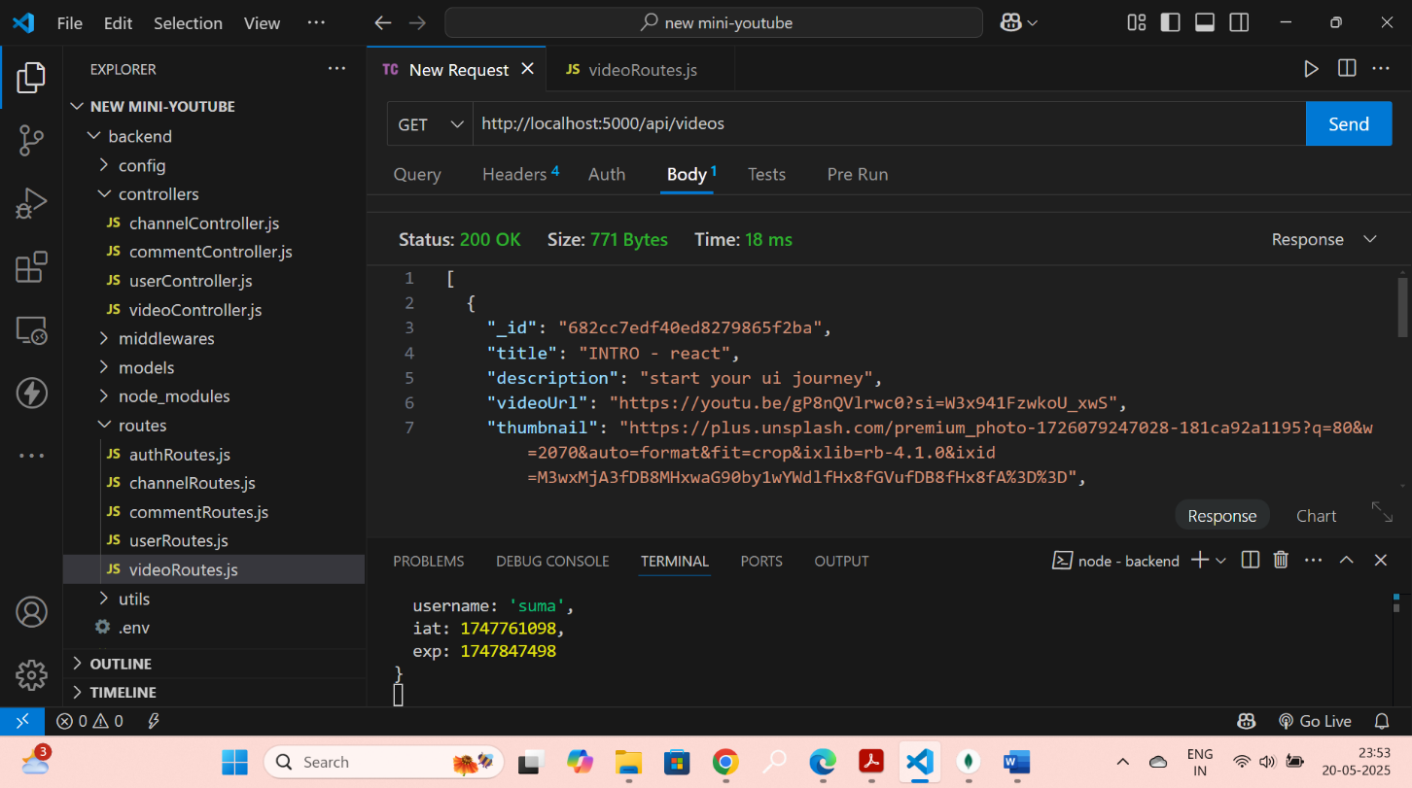

PUT: <http://localhost:5000/api/videos/:CHANNELID>

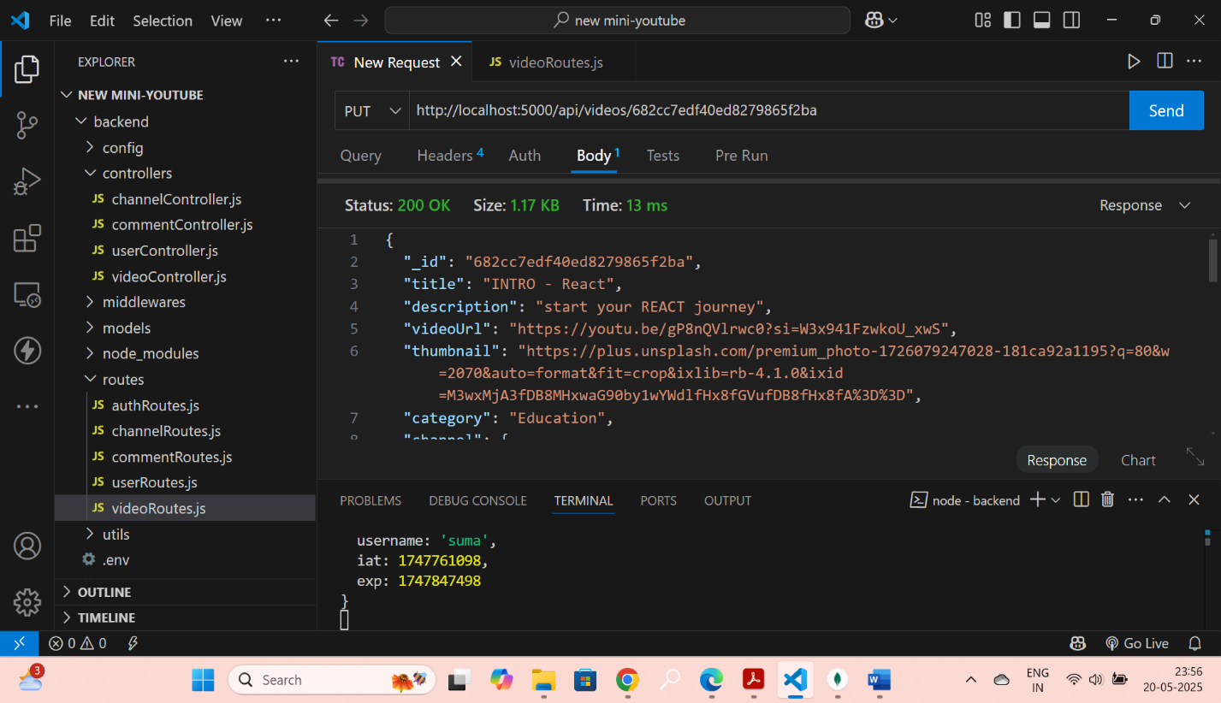

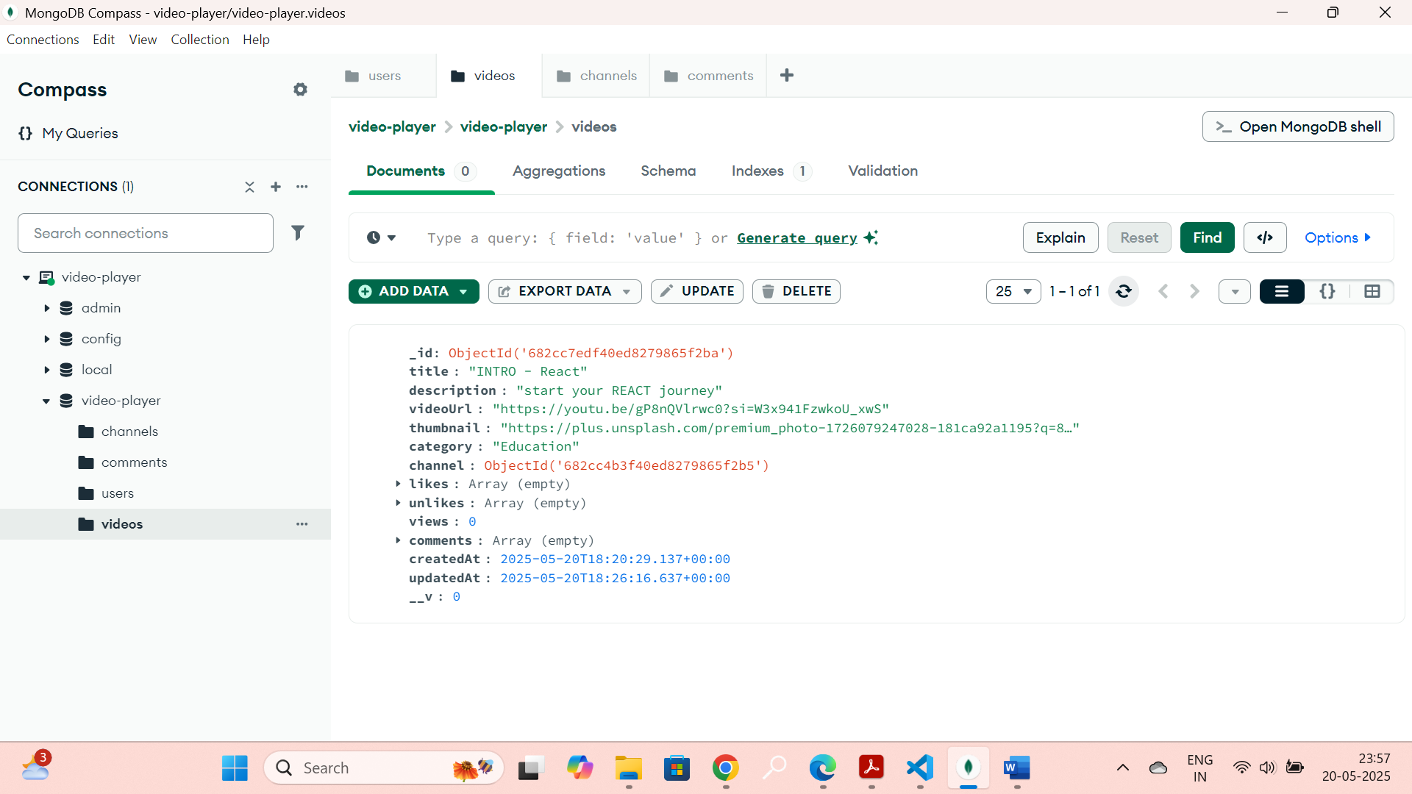

GET : <http://localhost:5000/api/videos>

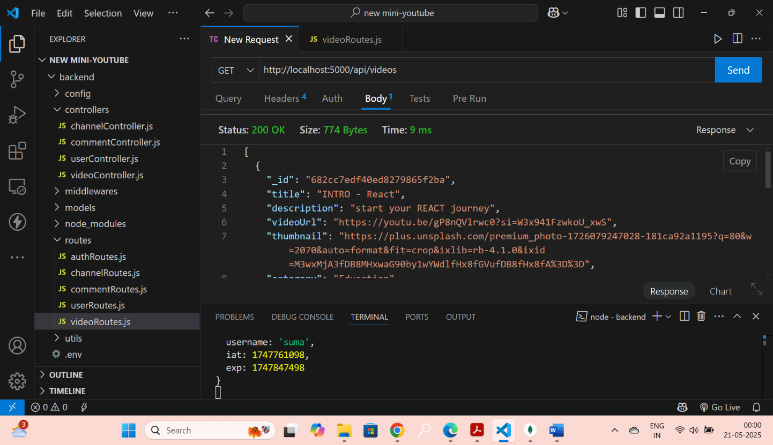

PUT : <http://localhost:5000/api/videos/>: CHANNELID

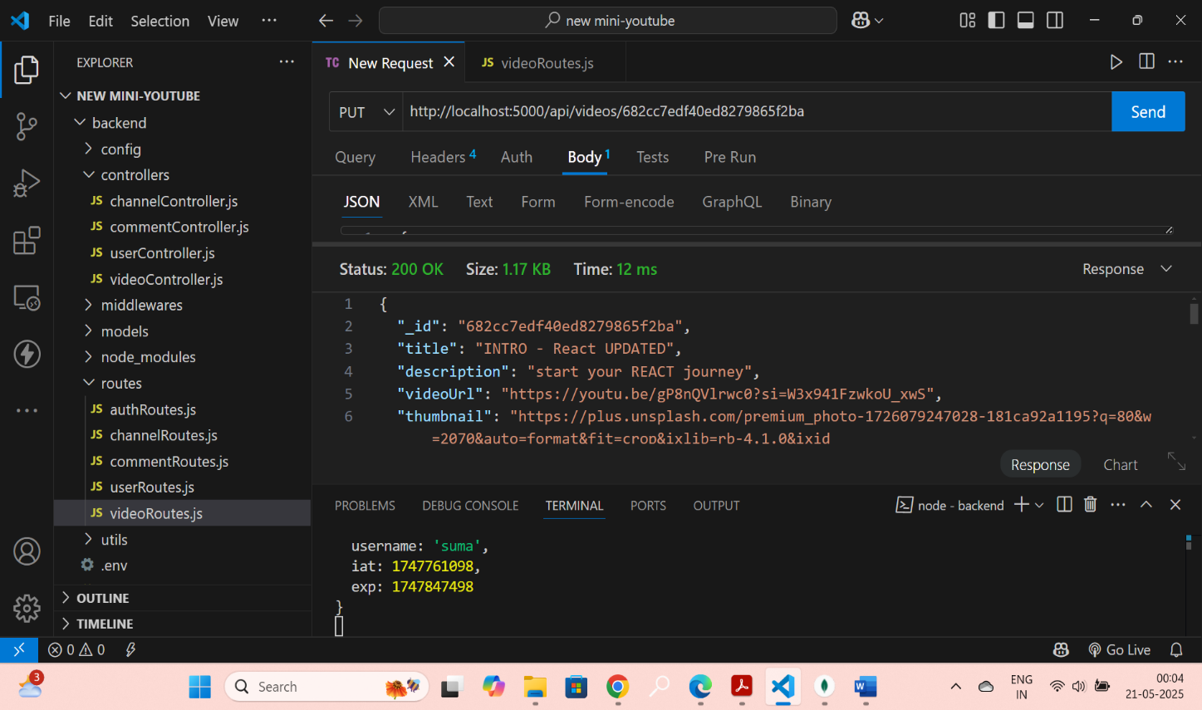

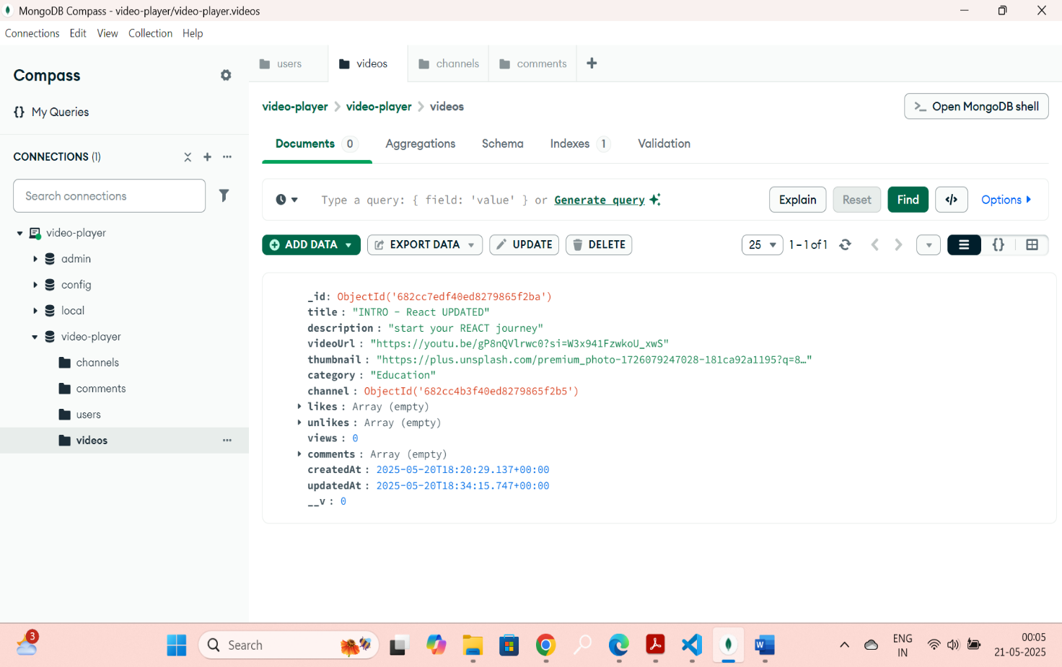

PUT : <http://localhost:5000/api/videos/like/:CHANNELID>

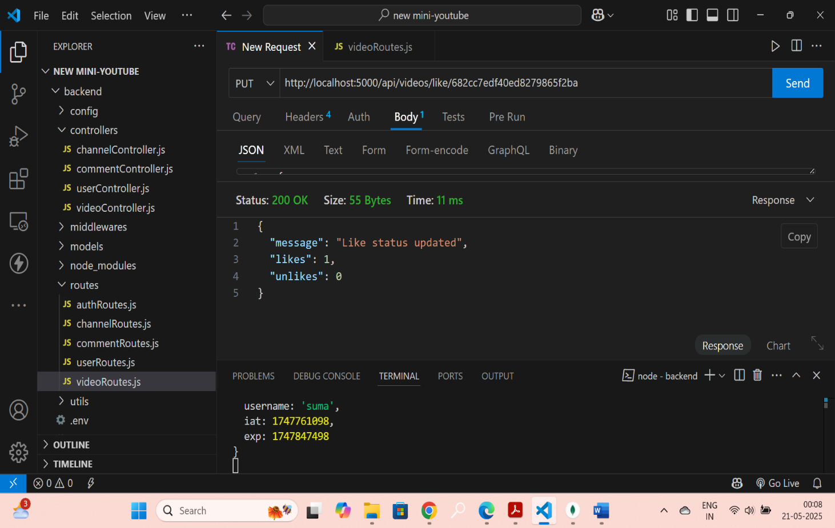

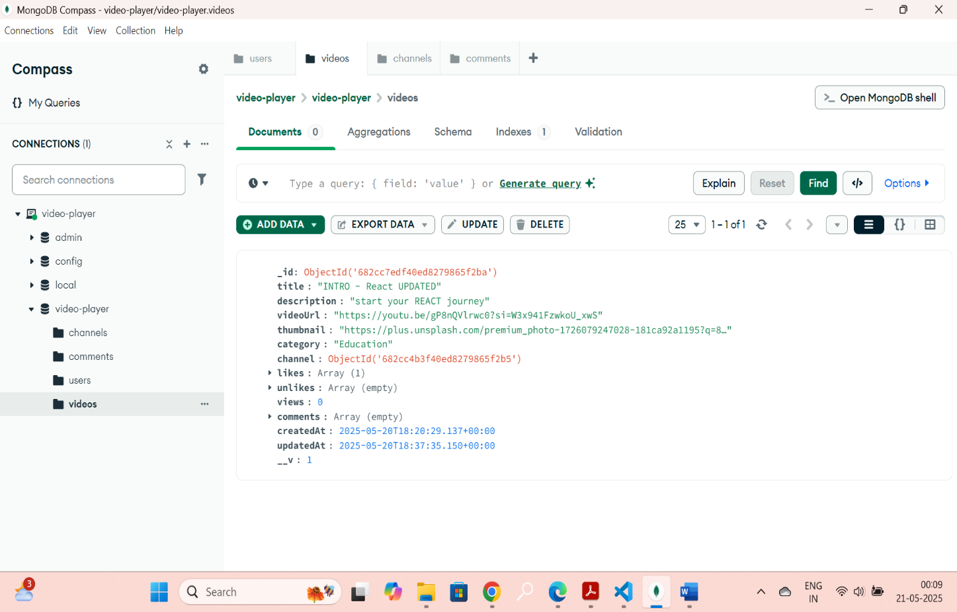

PUT : <http://localhost:5000/api/videos/unlike/:CHANNELID>

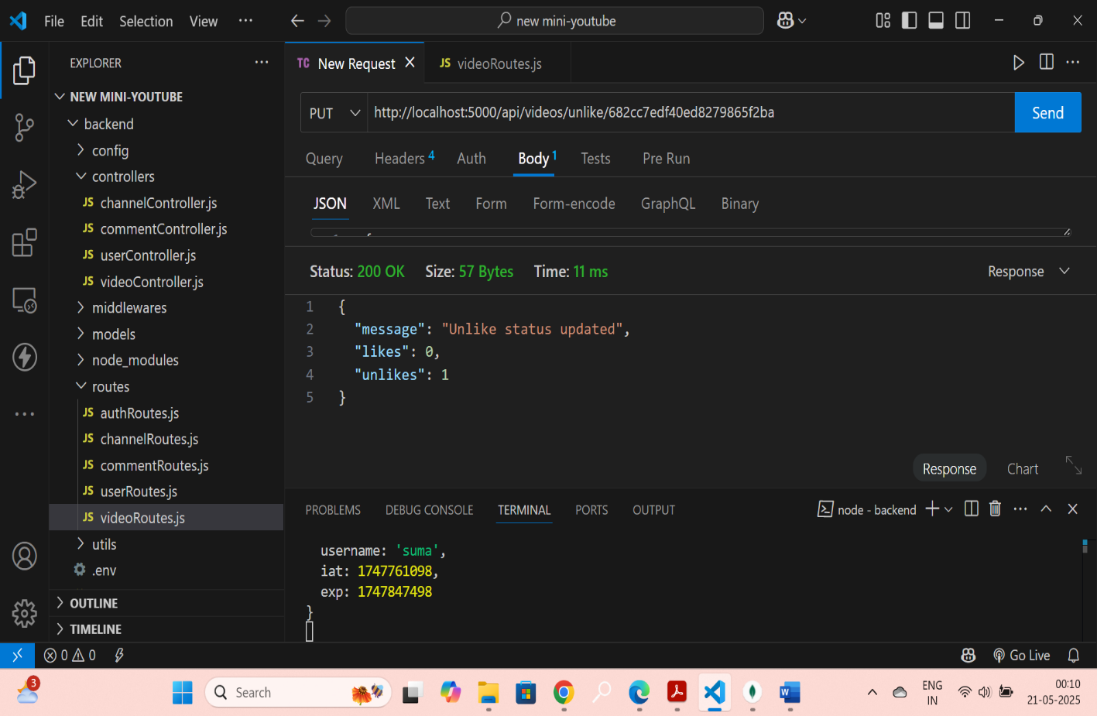

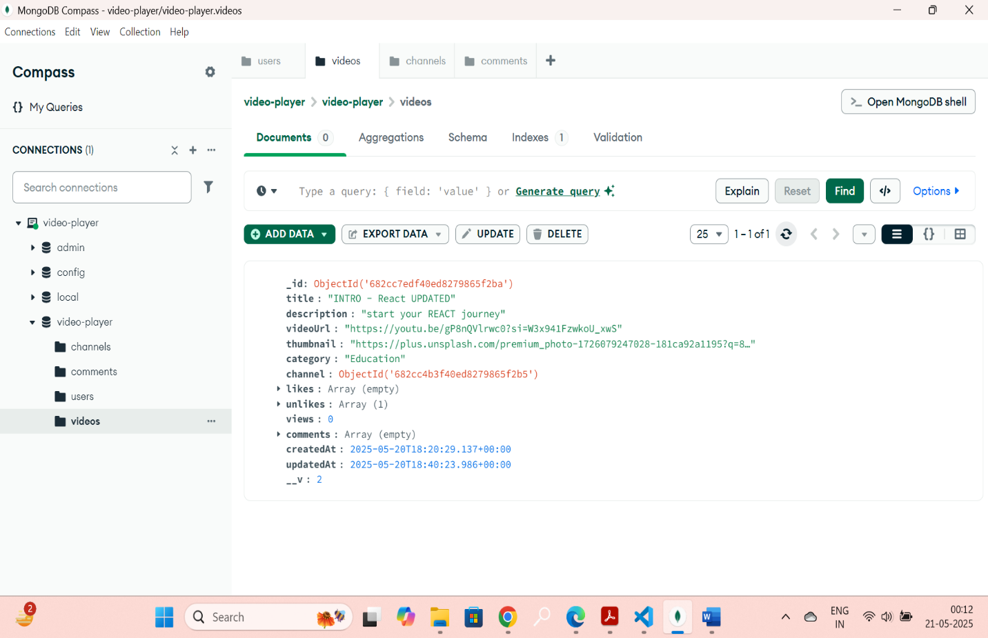

DELETE : <http://localhost:5000/api/videos/:CHANNELID>

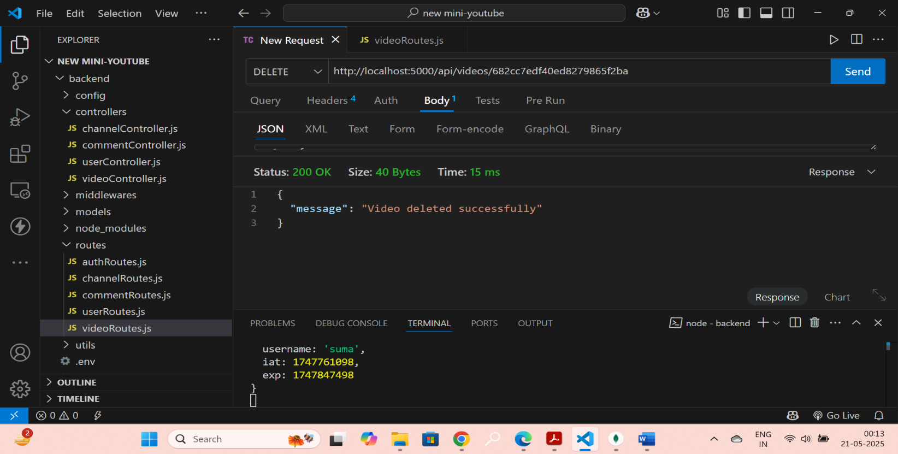

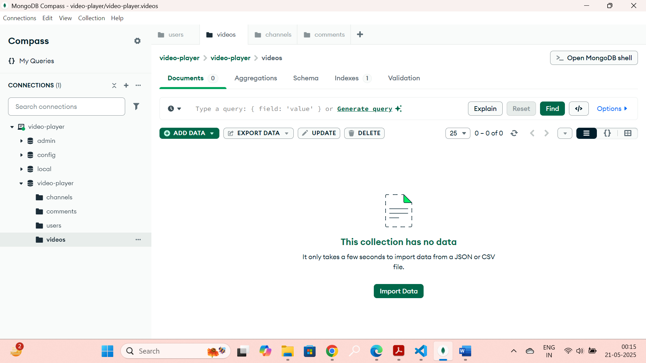

POST : <http://localhost:5000/api/comments>

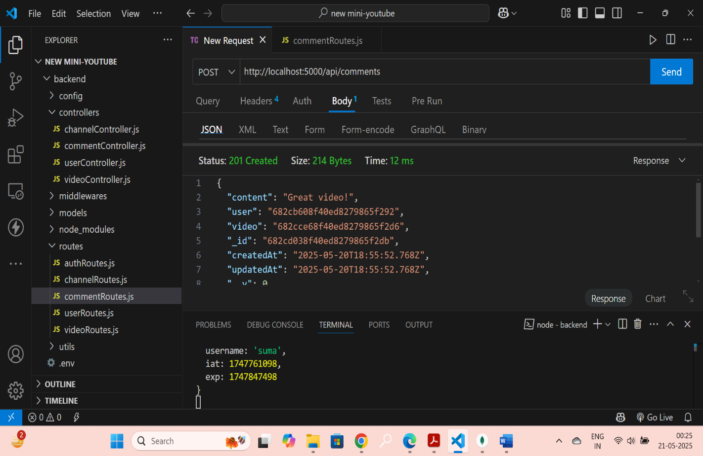

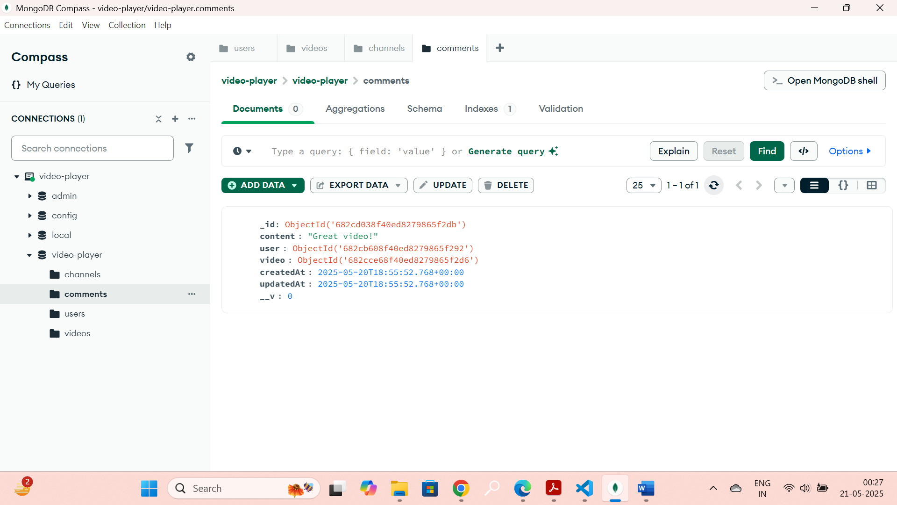

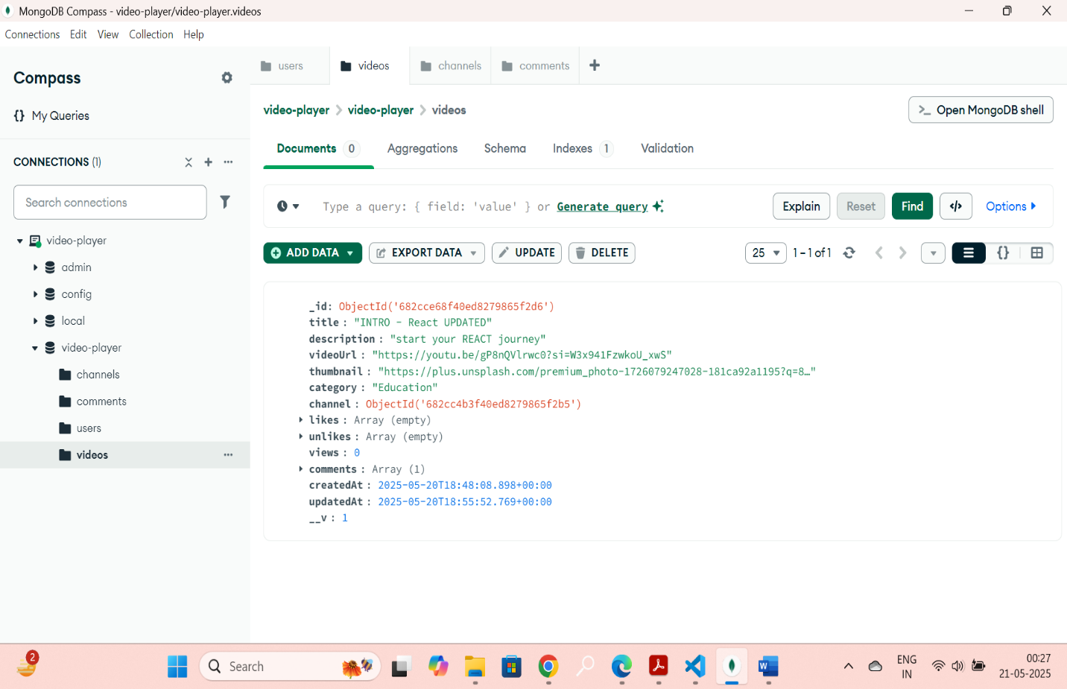

PUT: <http://localhost:5000/api/comments/:CHANNELID>

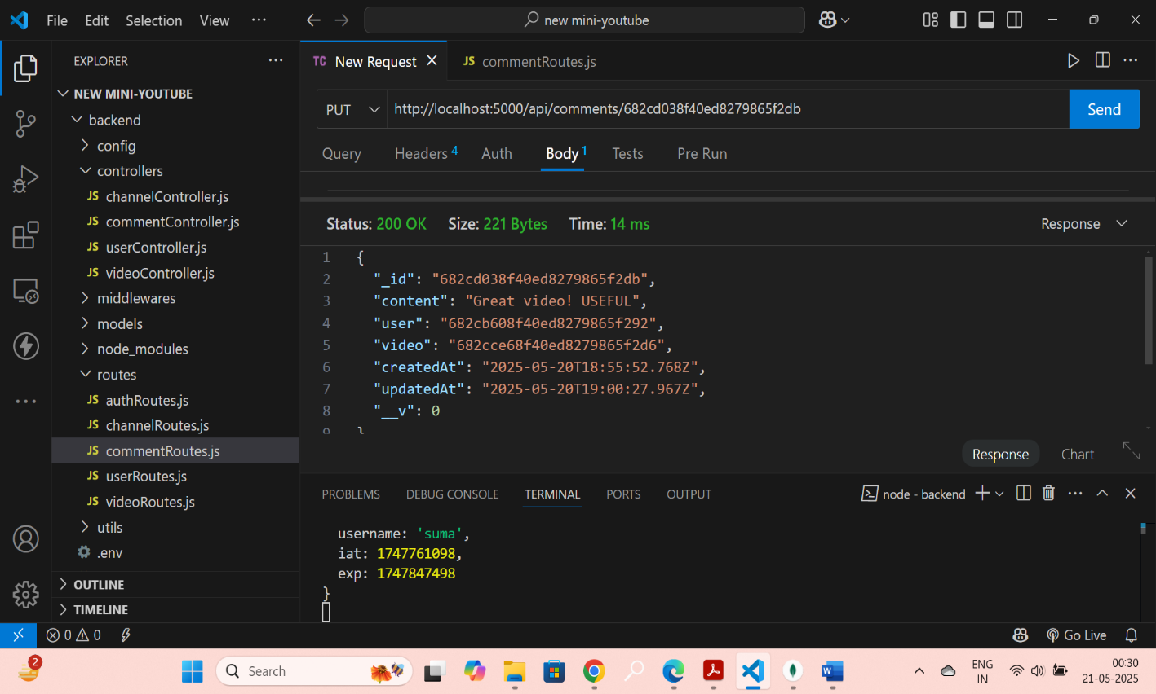

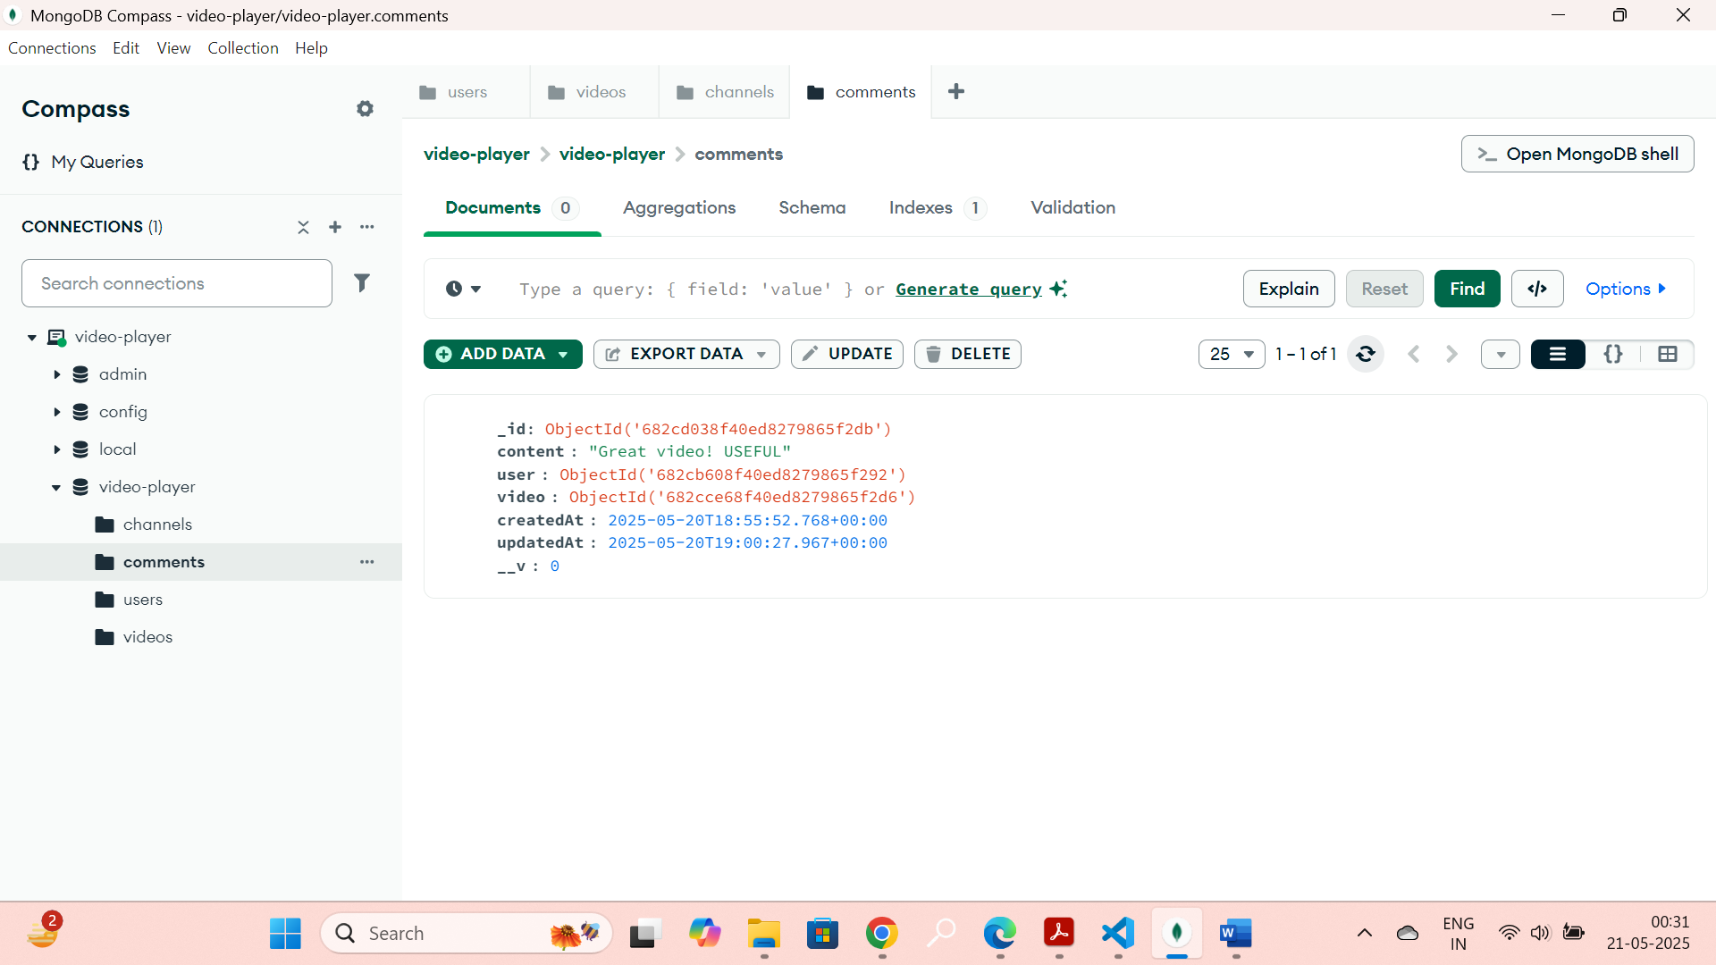

GET : <http://localhost:5000/api/comments/:VIDEOID>

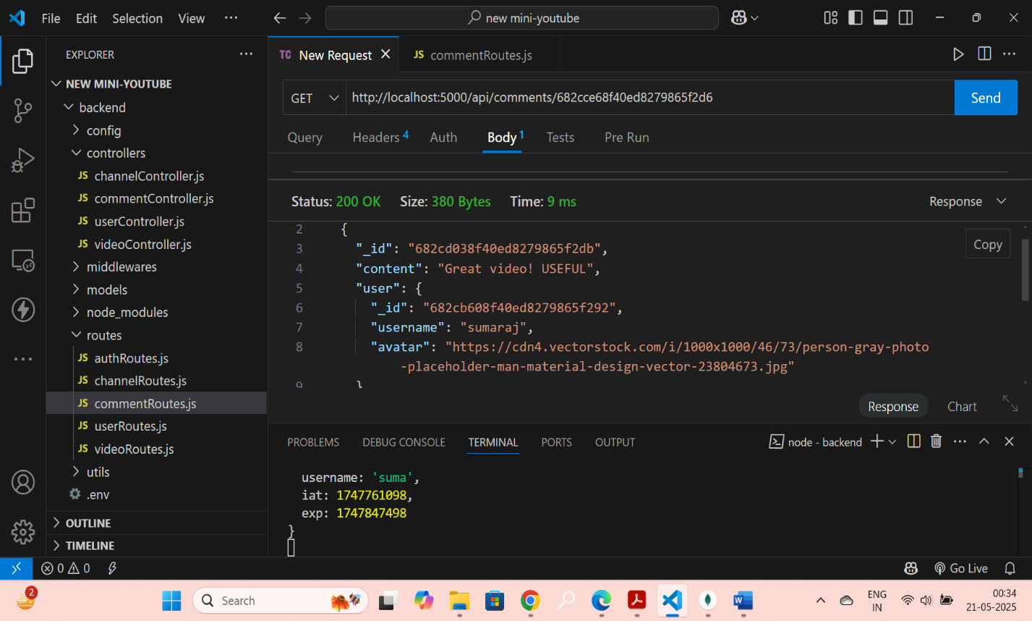

DELETE : : <http://localhost:5000/api/comments/:COMMENTID>

